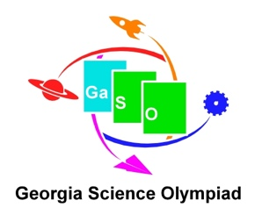
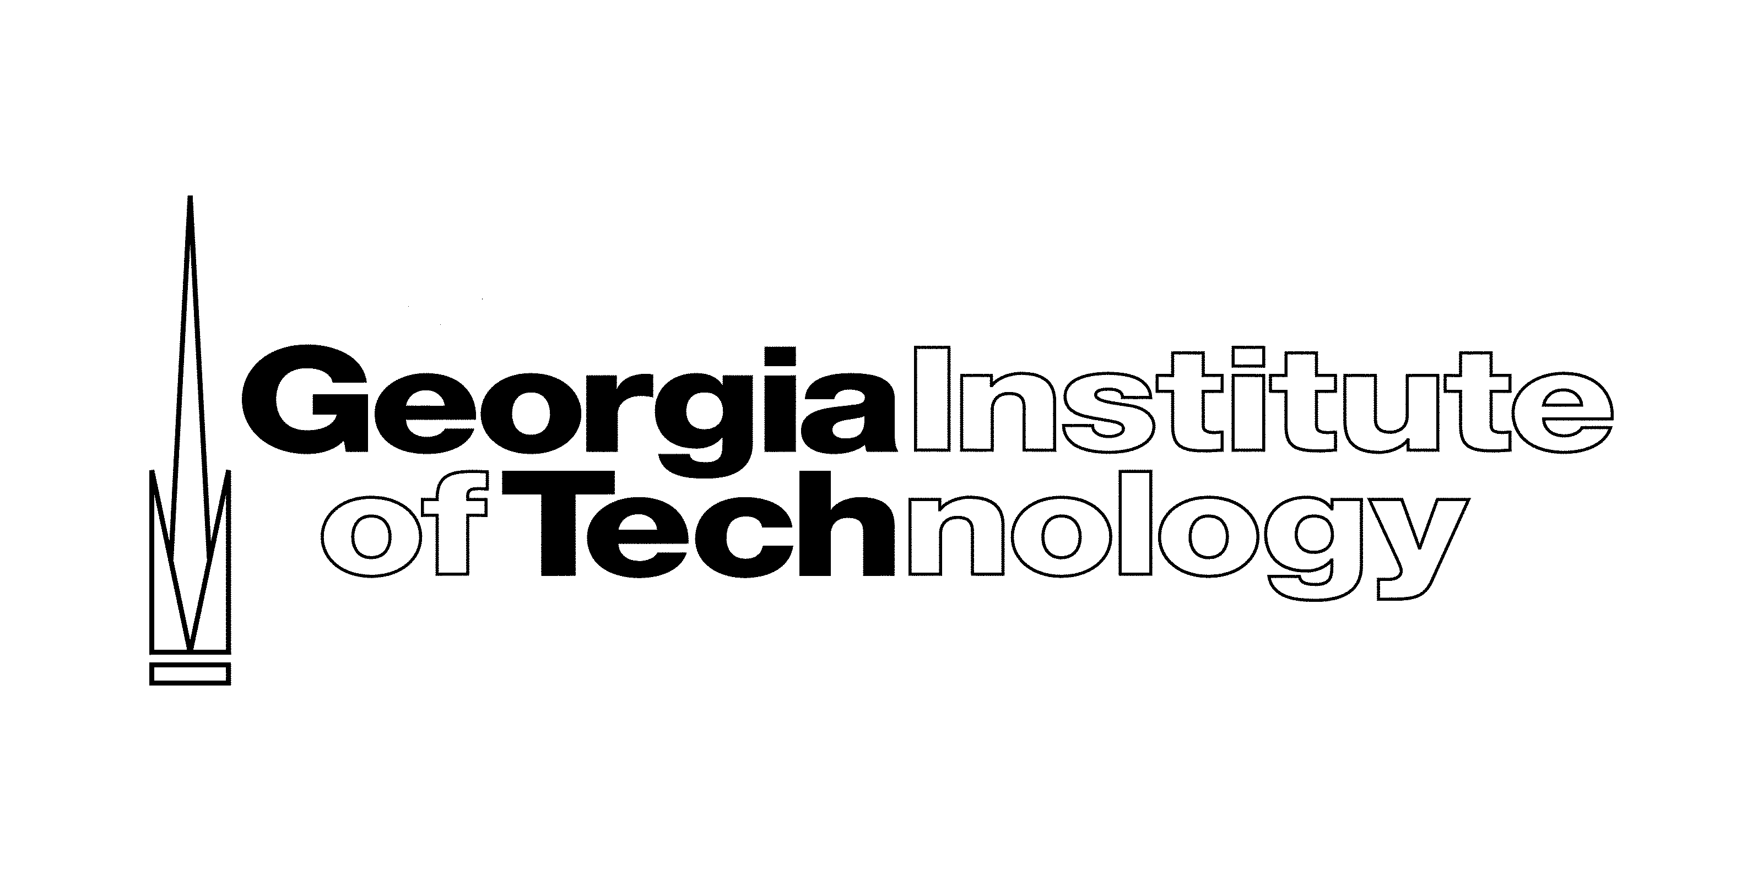

Science Olympiad at Georgia Tech
Behavior Management Policy

Tournament participants are expected to follow these basic rules:

- Follow the instructions of the Tournament Directors, Event Supervisors, Cluster Coordinators, and other adult volunteers.
- Do not harm yourself or others in any way.
- Treat other youth, staff, and visitors with respect.
- Georgia Tech is an open campus. Always travel with a buddy.
- Be kind to the environment and campus spaces.

For safety reasons, certain types of inappropriate behavior cannot be tolerated. The following behaviors will result in a participant’s disqualification from the tournament. If such misbehavior occurs, coaches will be notified immediately.

- Jeopardizing the health or safety of others.
- Destruction of property.
- Repeated cursing or profane language.
- Threatening violence.

Thank you for supporting our staff’s efforts to ensure the safety and well-being of all tournament participants. Please complete and sign the statement below for our records.

I, the 2018 Regional Science Olympiad Tournament Coach of ________________________________ High School, have received and read the Behavior Management Policy for the 2018 Regional Science Olympiad tournament that is held at Georgia Tech. I agree to abide by this policy as a condition of my team’s participation in this tournament, and I will discuss the basic rules of behavior with my students.

_____________________________________ _____________________
Coach’s Signature Date

